**Table of Contents**

1. Introduction 1

Project Domain / category 1

Purpose 1

Scope 2

Product Perspective 2

1. Requirements 3

Functional Requirements 3

Non-Functional Requirement 3

Use case Diagram 4

Grand Chart 5

# Introduction

## Project Domain / Category

## Web Application

## Purpose

The purpose of this SRS is to describe the requirements involved in developing an online ticket reservation system.

## Scope

The online ticket reservation system will be used by passengers who may be familiar or not familiar to the online train reservation process thus the scope of the project must be user friendly for both passengers and admin. This system will allow Passengers to create account in the System. Passenger who is member of the system can only reserve, cancel, view and print the train ticket. The passenger can reserve the train ticket by giving the required details like source, destination, date of journey and know the trains list. The passenger can select train and check availability. If available, give passenger details in the form, payment details andsubmit it for the processing. The Online Ticket Reservation System provides train ticket which passenger can view and print.

## Product perspective

### System interfaces

Any OS like Windows7, Linux, Mac OS.

### User interfaces:

* Passenger log-in / create profile.
* Ticket reservation process.
* Ticket cancellation process.
* View and print.
* Admin login-in.
* Seats and Fares updation process.

**Hardware interfaces:**

Minimum Hardware Requirements: The system will run on different hardware gadgets. Below are the minimum hardware Requirements for the smooth running of the system:

* 1GB RAM PC.
* 1.8Hz processor.
* 14” color monitor.
* 120GB HDD CPU.
* Proper running internet.

**Communications Interfaces:**

The main Communication link that the system will be using is the internet.

# Requirements

## Functional Requirements

## The system shall be internet oriented and require an online server.

## The system shall save the passengers’s details to a remote database service

## The system shall allow passengers to register and to log in their account

## The system will allow passenger to reserve train tickets.

## The system will allow passenger to cancel their reserved train tickets

## The system will allow passenger to view and print train ticket.

## The system will allow admin to manage passengers account, updates trains list, seats and fare.

## Non-Functional Requirements

1. **Performance Requirements:** The system is required a fair amount of speed especially while browsing through the trains list and availability of seats. The database shall be able to accommodate a minimum of 100000 records of passengers. The software will support multiple users.
2. **Safety Requirements:** The system is required provide a protection of the database.

### Use Case diagram:

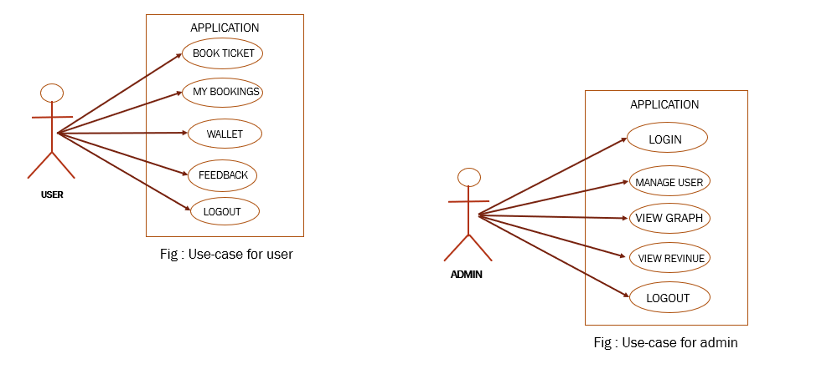

|  |  |  |
| --- | --- | --- |
| Project Proposal | Nowrin Islam Nishat | **10 Days** |
| Software Requirement Specification | Nowrin Islam Nishat | **10 Days** |
| Software Design | Nowrin Islam Nishat | **30 Days** |
| Coding | Nowrin Islam Nishat | **20 Days** |
| Software Testing | Nowrin Islam Nishat | **10 Days** |
| Project Finalization | Nowrin Islam Nishat | **10 Days** |

### GRANT CHART

|  |  |  |  |  |  |  |  |  |  |  |
| --- | --- | --- | --- | --- | --- | --- | --- | --- | --- | --- |
| **Duration** | | | | | | | | | | |
|  |  |  |  |  |  |  |  |  |  |  |
|  |  | 7 days | 7 days | 7 days | 7 days | 7 days | 7 days | 7 days | 7 days | 7 days |
|  |  |  |  |  |  |  |  |  |  |  |
| **Project Proposal** | |  |  |  |  |  |  |  |  |  |
| **SRS** |  |  |  |  |  |  |  |  |  |  |
| **Designing** | |  |  |  |  |  |  |  |  |  |
| **Coding** |  |  |  |  |  |  |  |  |  |  |
| **Testing** | |  |  |  |  |  |  |  |  |  |
| **Finalization** | |  |  |  |  |  |  |  |  |  |

### Figure: Time frames for project implementation

|  |  |  |  |
| --- | --- | --- | --- |
| **Hardware Requirements** | | | |
| **Processor** | **RAM** | | **Hard Disk Space** |
| Pentium II or higher | 64 Mb or higher | | 128 Mb or higher |
| **Software Requirements** | | | |
| **Operating System** | | **Database** | |
| For user no specific OS is required. The server machine must have Windows XP/Vista/7 along with .NET framework 4 and IIS. | | SQL Server 2008 | |

Table: Project Resource

### 